WHITE BAND ASSOCIATES
CYBER SECURITY INTERNSHIP PROGRAMME
Cyber Security Task 01
Personal Security Audit & Cyber Awareness Assessment

Prepared By | Pratiksha Vishwakarma
Device / Hostname | PRATIKSHA-VISHW (LAPTOP-EIKT8S23)
Operating System | Windows 11 Home Single Language – Build 26200.8655
System Model | HP Laptop 15s-eq2xxx
Processor | AMD64 Family 23 Model 104 – ~2100 MHz
RAM | 15,694 MB (Total Physical Memory)

Part A Device Security Assessment
A full security assessment was conducted on the personal laptop PRATIKSHA-VISHW running Windows 11. The following sections document the operating system details, update status, antivirus configuration, and firewall settings, all verified using built-in Windows tools and command-line utilities.

A.1 – Operating System & Version
The OS version was verified using both the winver graphical dialog (Run → winver) and the systeminfo command from the Command Prompt. Both methods confirmed the same build details.

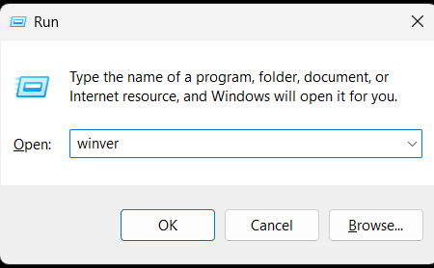
Screenshot 1 – Run dialog: winver command
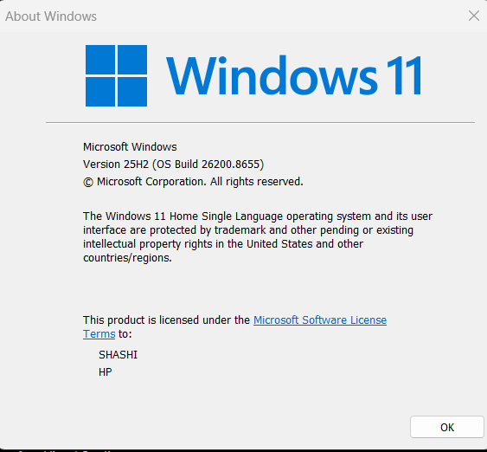
Screenshot 2 – About Windows: Version 25H2, OS Build 26200.8655

Parameter | Detail
OS Name | Microsoft Windows 11 Home Single Language
OS Version | 10.0.26200 – Build 26200.8655
Release | Version 25H2
System Manufacturer | HP
System Model | HP Laptop 15s-eq2xxx
Processor | AMD64 Family 23 Model 104 Stepping 1 AuthenticAMD – ~2100 MHz
Total Physical Memory | 15,694 MB
System Type | x64-based PC
Boot Device | \Device\HarddiskVolume1
Time Zone | UTC+05:30 – Chennai, Kolkata, Mumbai, New Delhi

A.2 – systeminfo Command Output
The systeminfo command was executed in Command Prompt and confirmed the full system profile including hotfixes, network adapters, and virtualisation-based security.

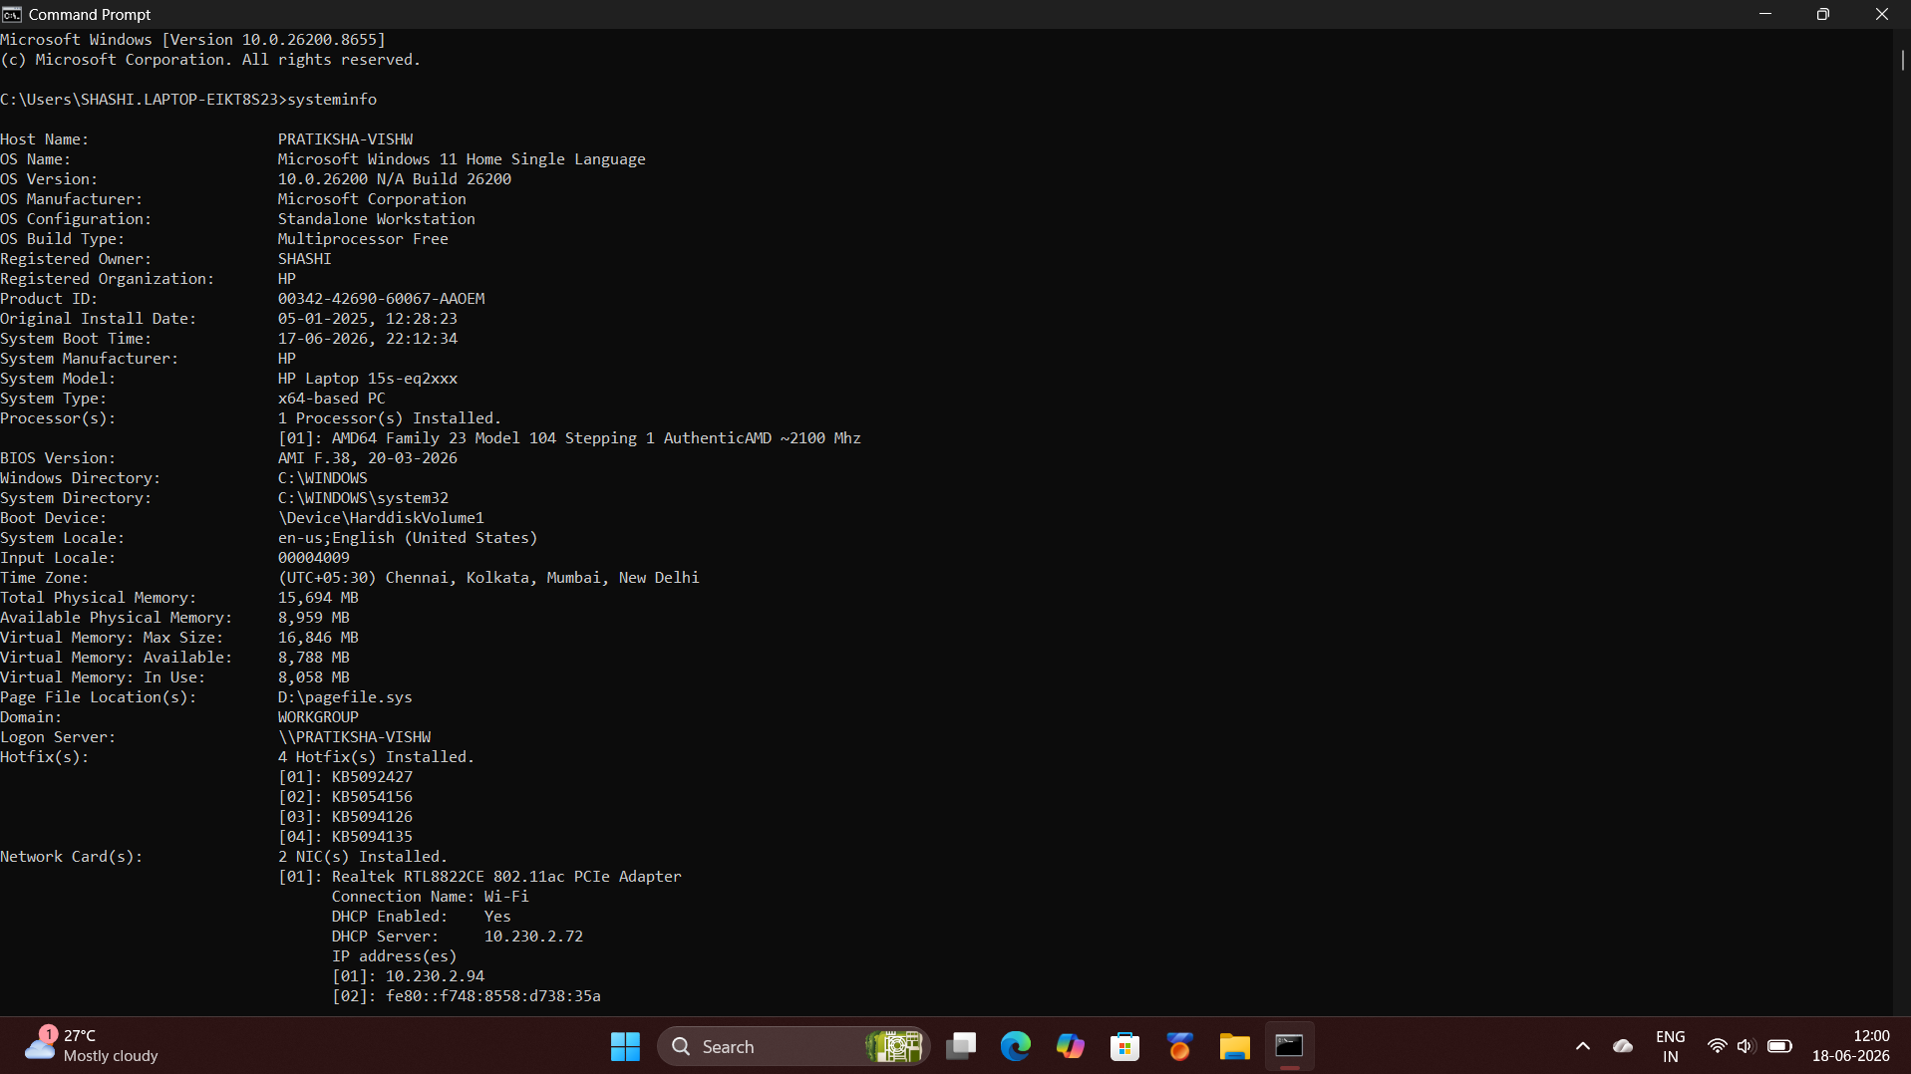
Screenshot 3 – systeminfo output (Host, OS, Hardware, Network)
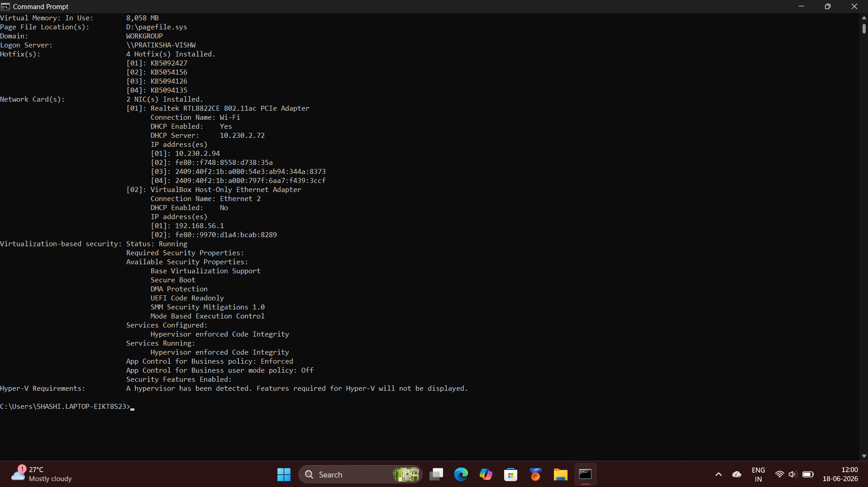
Screenshot 4 – systeminfo output (Network cards, VBS, Hyper-V)

Hotfixes Installed: KB5092427 | KB5054156 | KB5094126 | KB5094135 (4 patches applied)

A.3 – Windows Update Status
Windows Update was checked via Settings → Windows Update. The system confirmed it is fully up to date, with automatic updates enabled.

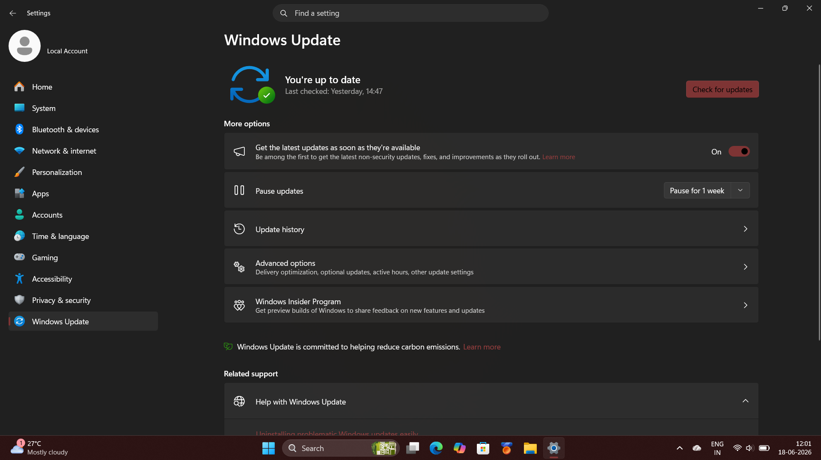
Screenshot 5 – Windows Update: System is up to date

Check | Result
Update Status | ✔ Up to Date
Last Checked | Yesterday, 14:47
Automatic Updates | ON – latest updates received as soon as available

A.4 – Antivirus Assessment
Windows Defender (Microsoft Defender Antivirus) is the active antivirus solution. Its status was verified through Windows Security Centre and confirmed via the sc query WinDefend command in an elevated Command Prompt.

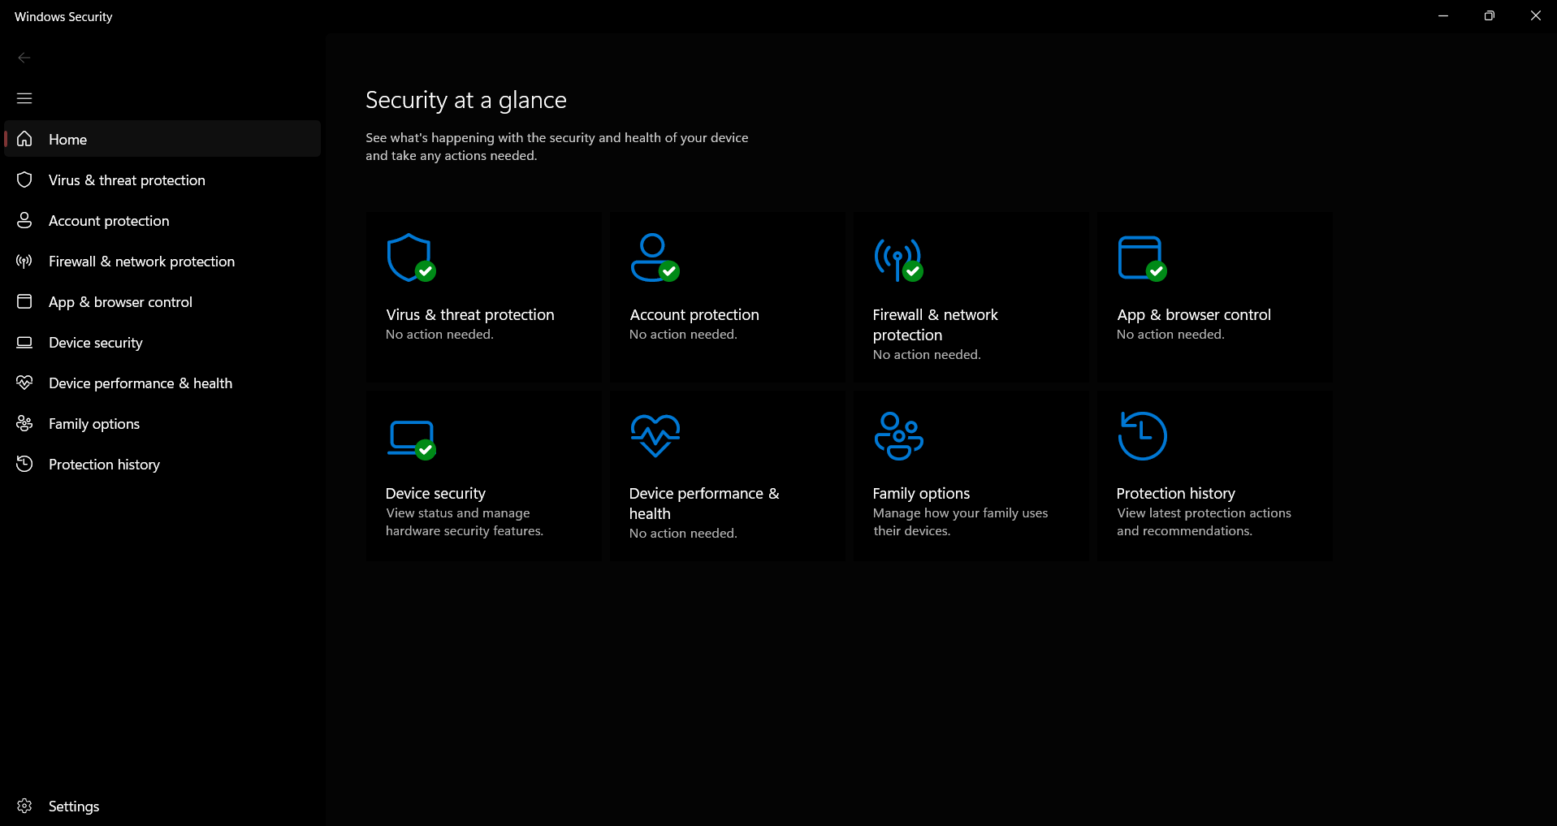
Screenshot 6 – Windows Security: Security at a glance – all green
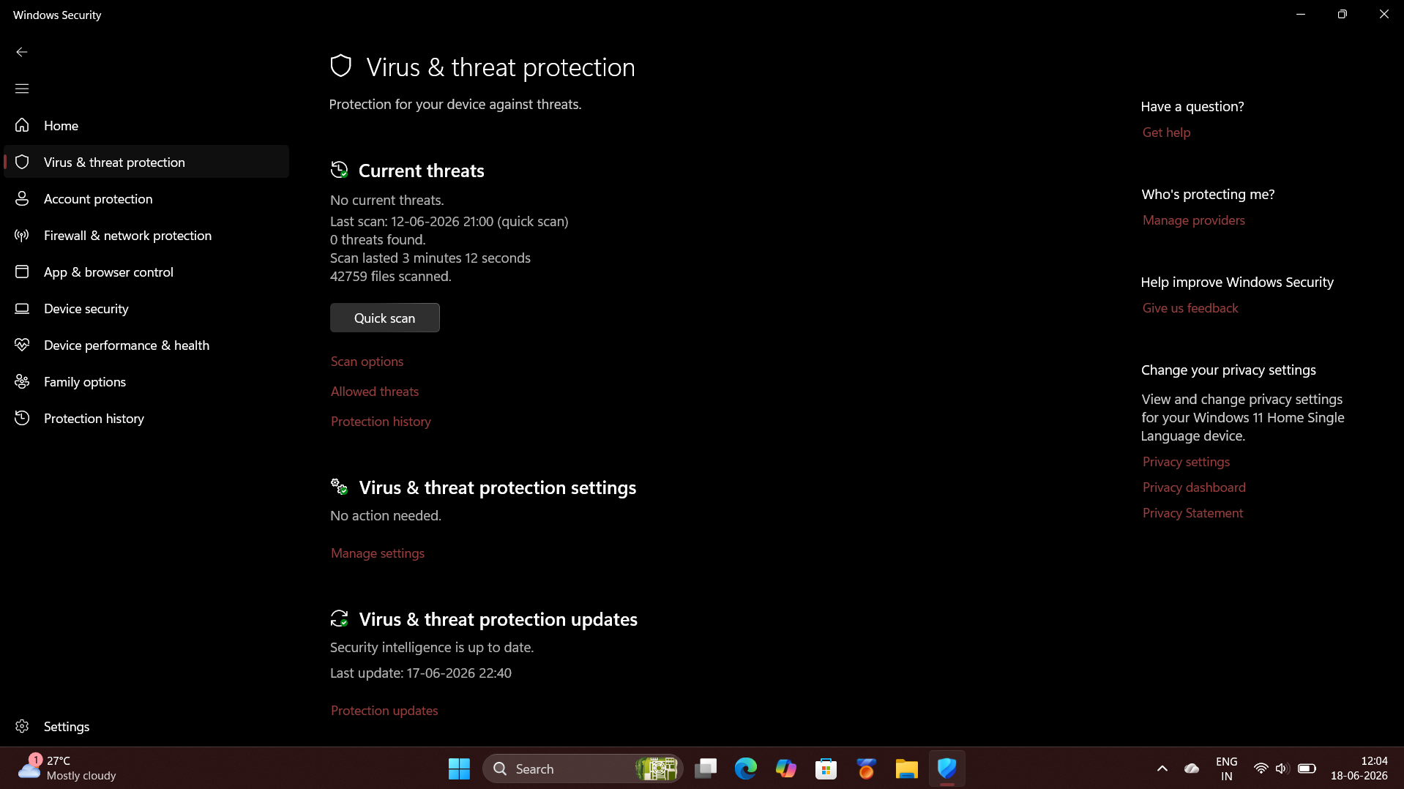
Screenshot 7 – Virus & Threat Protection: No current threats, 42,759 files scanned
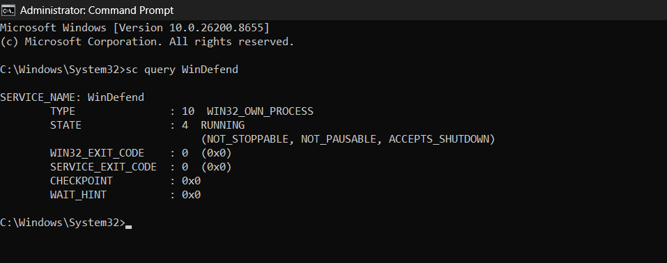
Screenshot 8 – sc query WinDefend: STATE 4 RUNNING

Antivirus Parameter | Detail
Antivirus Installed | Yes – Microsoft Defender Antivirus (WinDefend)
Service State | Running (NOT_STOPPABLE, NOT_PAUSABLE)
Current Threats | None – No threats found
Last Scan | Most Recent Quick Scan – 42,759 files scanned, 0 threats found
Security Intelligence | Up to Date – Latest definitions applied
Real-Time Protection | Enabled

A.5 – Firewall Assessment
The Windows Defender Firewall status was verified through Windows Security → Firewall & Network Protection, and confirmed in detail using the netsh advfirewall show allprofiles command in an elevated Command Prompt.

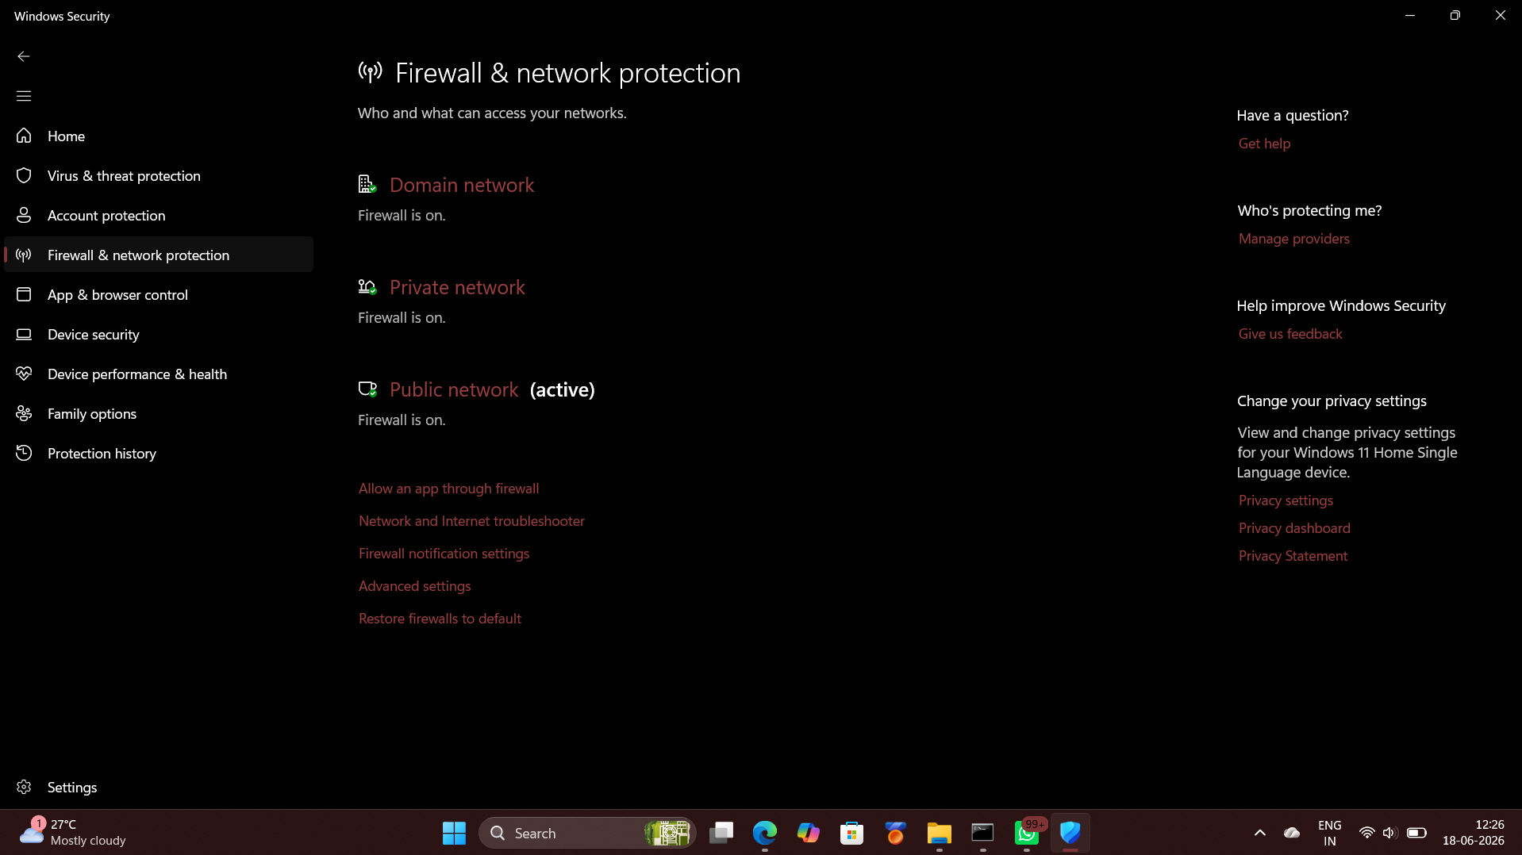
Screenshot 9 – Windows Security: Firewall ON for Domain, Private and Public networks
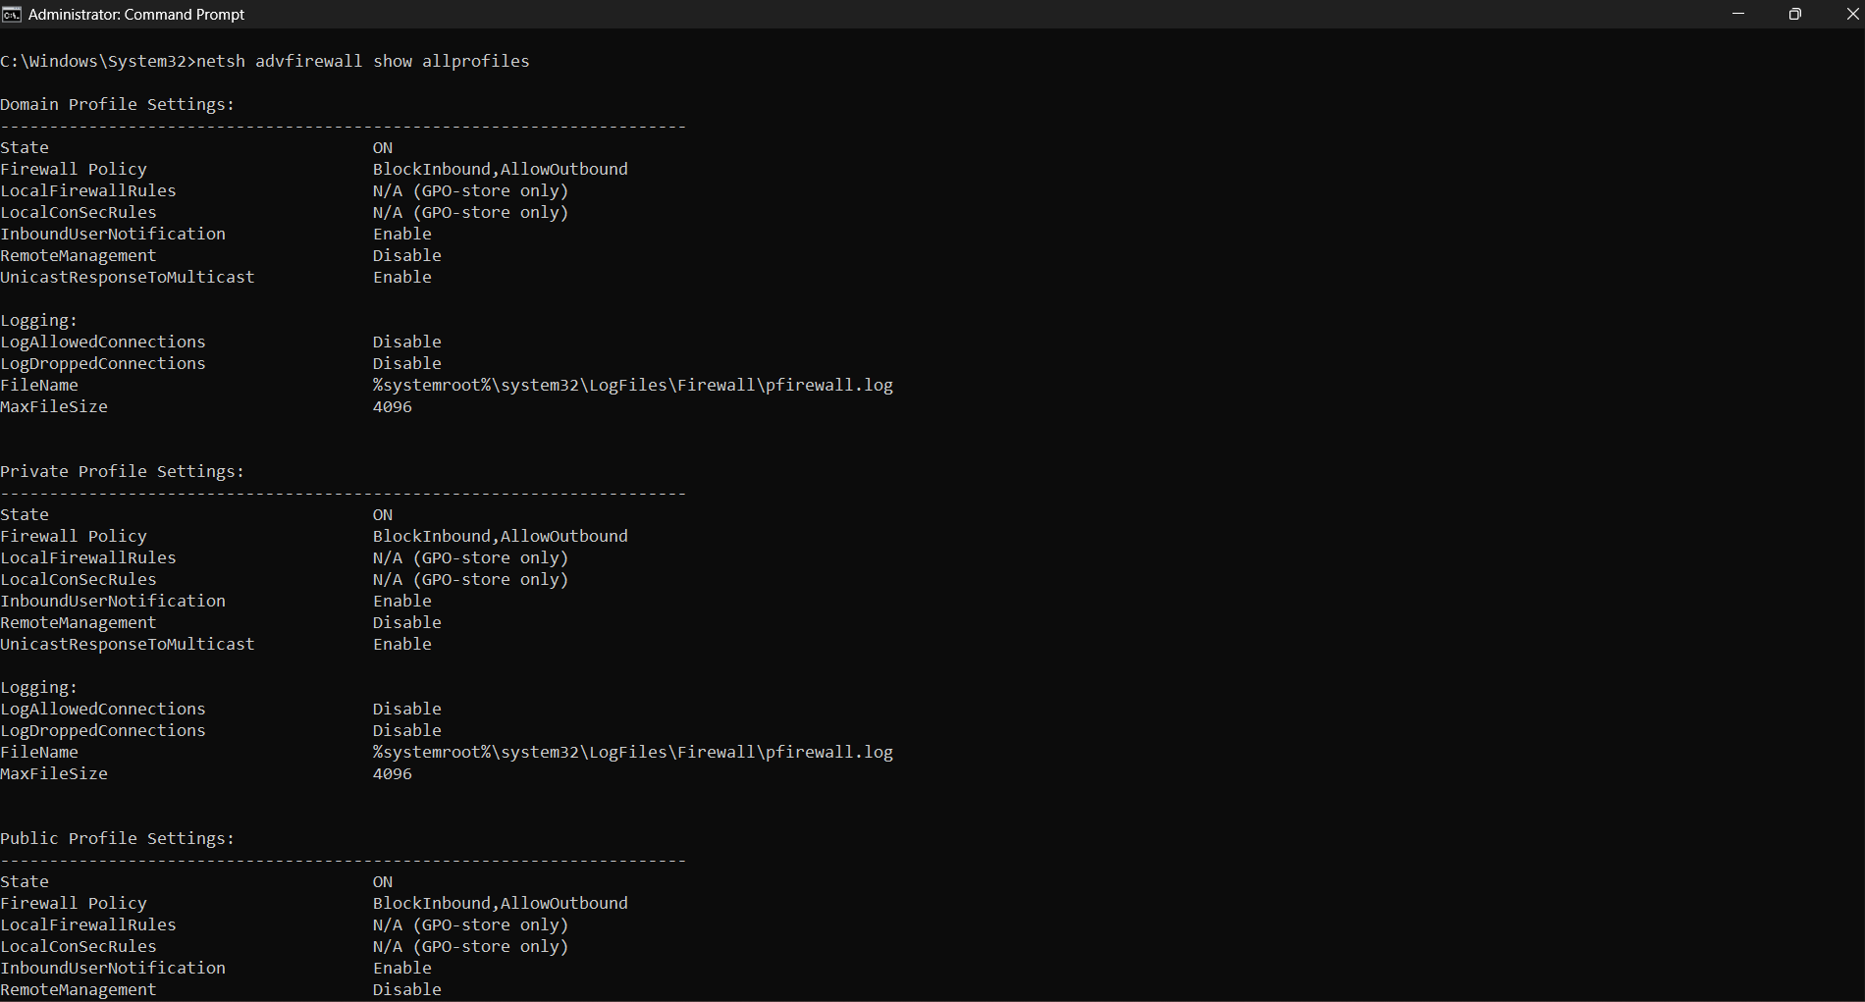
Screenshot 10 – netsh advfirewall: Domain, Private & Public profiles all ON
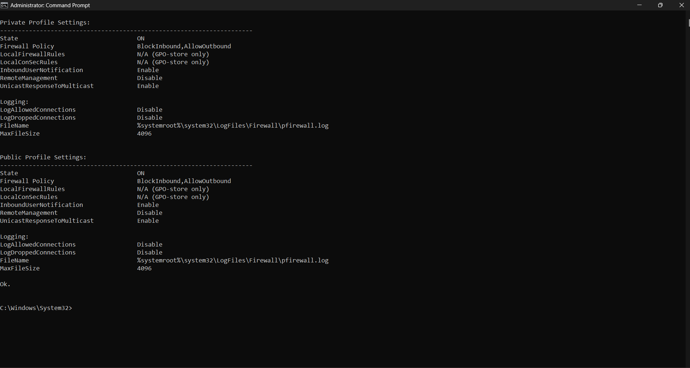
Screenshot 11 – netsh advfirewall: Private & Public profile detail (BlockInbound, AllowOutbound)

Firewall Profile | State | Policy | Inbound Notification
Domain | ON | BlockInbound, AllowOutbound | Enabled
Private | ON | BlockInbound, AllowOutbound | Enabled
Public (Active) | ON | BlockInbound, AllowOutbound | Enabled

A.6 – Security Assessment Summary

Security Check | Status | Detail
Operating System | Yes ✔ | Windows 11 Home – Build 26200.8655
System Updated | Yes ✔ | Up to date – 4 hotfixes applied
Antivirus Installed | Yes ✔ | Microsoft Defender – Running, 0 threats
Firewall Enabled | Yes ✔ | ON across Domain, Private & Public profiles
VBS / Secure Boot | Yes ✔ | Virtualization-Based Security running

Part B Password Security Review
Password security is the first line of defence for any digital account or system. The following section explains the key principles of strong password management based on established cybersecurity best practices.

B.1 – What Makes a Strong Password?
A strong password is one that is difficult for both humans and automated tools (such as brute-force or dictionary-attack programs) to guess or crack. It must combine several characteristics that increase its complexity and unpredictability:

- Length of at least 12–16 characters — longer passwords grow exponentially harder to crack.
- A mix of uppercase and lowercase letters, digits (0–9), and special characters (!@#$%^&*).
- No dictionary words, common phrases, or keyboard patterns (e.g. ‘qwerty’, ‘123456’).
- No personal information such as name, date of birth, phone number, or pet names.
- Randomness — ideally generated by a password manager rather than chosen by the user.

B.2 – Why Should Passwords Be Unique?
Using the same password across multiple accounts creates a cascading failure risk known as credential stuffing. When a data breach exposes a username and password from one service, attackers automatically test those credentials across hundreds of other services. A single leaked password can therefore compromise banking, email, social media, and work accounts simultaneously. Unique passwords ensure that a breach of one account cannot unlock others.

B.3 – What is Multi-Factor Authentication (MFA)?
Multi-Factor Authentication (MFA) is a security mechanism that requires a user to provide two or more independent verification factors before granting access to an account. These factors fall into three categories:

- Something you know — password or PIN.
- Something you have — a one-time code sent to your phone (SMS/authenticator app) or a hardware security key.
- Something you are — biometric data such as a fingerprint or facial recognition.

Even if an attacker obtains a user’s password, MFA prevents unauthorised access because they cannot supply the second factor. MFA is widely regarded as one of the most effective controls against account takeover attacks.

B.4 – What Are the Risks of Password Reuse?
- Credential stuffing attacks: leaked credentials from one breach are tested across other services.
- Account takeover: a single compromised password can unlock email, banking, and social accounts.
- Lateral movement: in an organisation, reused passwords allow attackers to move from one system to another.
- Data exposure: if an attacker accesses email via a reused password, they can reset passwords for every linked account.
- Reputation damage: compromised social or professional accounts can be used to spread malware or misinformation in the victim’s name.

B.5 – Personal Password Policy
The following five best-practice rules form a personal password policy to be applied across all digital accounts:

# | Policy Rule | Explanation
1 | Minimum 14 characters | Length is the single most effective factor in increasing password strength against brute-force attacks.
2 | Use uppercase, lowercase, numbers & symbols | Combining all four character classes vastly increases the number of possible combinations.
3 | Unique password for every account | Prevents credential stuffing; one breach cannot cascade to other services.
4 | Enable MFA on all critical accounts | Adds a second verification layer so a stolen password alone is insufficient for access.
5 | Store passwords in a reputable password manager | Eliminates the need to memorise passwords and discourages reuse or weak choices.

Part C Online Account Security Check
Three online accounts were reviewed for core security posture. Actual passwords are not disclosed; the review focuses on the presence of key protective controls.

Account | MFA Enabled | Strong Password | Recovery Email | Overall
Google Account | Yes ✔ | Yes ✔ | Yes ✔ | Secure
GitHub | Yes ✔ | Yes ✔ | Yes ✔ | Secure
LinkedIn | Yes ✔ | Yes ✔ | Yes ✔ | Secure

Note: Actual passwords have not been disclosed in this report. All assessments are based on account security settings review only.

C.1 – Findings & Observations
All three accounts reviewed have Multi-Factor Authentication (MFA) enabled, use strong unique passwords stored in a password manager, and have a verified recovery email configured. This configuration provides strong protection against common account compromise methods including phishing, credential stuffing, and brute-force attacks.
- Google: Two-Step Verification enabled via Google Authenticator app. Recovery email and phone configured.
- GitHub: Two-factor authentication enabled via authenticator app. SSH key added as additional credential.
- LinkedIn: Two-step verification enabled via authenticator app. Recovery email verified.

Part D Cyber Threat Research
The five major cyber threats below are explained in plain language including definitions, documented real-world examples, and actionable prevention methods.

D.1 – Phishing
Definition
Phishing is a social engineering attack in which a cybercriminal impersonates a trusted entity — a bank, tech company, government body, or known colleague — via email, SMS, or a fake website, with the intent of tricking the target into revealing sensitive information such as login credentials, credit card numbers, or OTPs.
Real-World Example
In 2016, John Podesta, campaign chairman for Hillary Clinton, received a phishing email disguised as a legitimate Google security alert. A staff member mistakenly declared it ‘legitimate’, Podesta entered his credentials on a fake Google login page, and his emails were subsequently exfiltrated and published — a breach that significantly impacted the U.S. presidential election.
Prevention Methods
- Enable MFA on all accounts so that stolen passwords alone are insufficient.
- Verify sender email addresses carefully; look for subtle misspellings or impersonation domains.
- Never click links in unsolicited emails — navigate directly to official websites.
- Use an email security gateway or spam filter to block phishing messages.
- Conduct regular phishing simulation training for staff or personal awareness.

D.2 – Malware
Definition
Malware (malicious software) is a broad term for any program or code designed to damage, disrupt, or gain unauthorised access to a computer system. Categories include viruses, trojans, spyware, adware, ransomware, and worms.
Real-World Example
The Emotet trojan, originally a banking malware first detected in 2014, evolved into one of the most prolific malware distribution networks in history. It spread via phishing emails containing malicious Word documents, silently installed itself, and then downloaded secondary payloads such as TrickBot and Ryuk ransomware onto victims’ systems.
Prevention Methods
- Keep operating systems and all software fully patched and updated.
- Install and maintain a reputable antivirus/EDR solution with real-time scanning.
- Never download software from unofficial or untrusted sources.
- Disable macros in Microsoft Office documents received from external sources.
- Take regular offline or cloud backups to enable recovery without paying ransoms.

D.3 – Ransomware
Definition
Ransomware is a specific type of malware that encrypts a victim’s files or locks their system and demands a ransom — typically in cryptocurrency — in exchange for the decryption key. Modern ransomware variants also exfiltrate data and threaten to publish it publicly (double extortion).
Real-World Example
The WannaCry ransomware attack of May 2017 exploited a critical Windows vulnerability (EternalBlue / MS17-010). It spread to over 200,000 systems in 150 countries within 72 hours, encrypting files and demanding Bitcoin payments. The UK’s National Health Service was severely impacted, with thousands of appointments cancelled and ambulances diverted.
Prevention Methods
- Apply security patches immediately, especially for critical vulnerabilities.
- Maintain regular offline or immutable backups to restore data without paying ransom.
- Implement network segmentation to limit the spread of infections.
- Restrict user privileges using the principle of least privilege.
- Deploy email filtering to block ransomware delivery via phishing attachments.

D.4 – Social Engineering
Definition
Social engineering is the psychological manipulation of people into performing actions or disclosing confidential information. Rather than exploiting software vulnerabilities, social engineers exploit human psychology — trust, urgency, fear, or authority — to bypass security controls.
Real-World Example
In 2020, Twitter suffered a major security breach when attackers called Twitter employees and impersonated IT staff, convincing them to grant access to internal admin tools. Attackers then used these tools to hijack the verified accounts of Barack Obama, Elon Musk, and others to promote a cryptocurrency scam, collecting over $100,000 in Bitcoin.
Prevention Methods
- Train all staff to recognise and report social engineering tactics (pretexting, vishing, baiting).
- Verify all requests for sensitive access via an independent channel before complying.
- Enforce strict identity verification procedures for IT support and admin access requests.
- Cultivate a security-aware culture where questioning unusual requests is encouraged.

D.5 – Data Breach
Definition
A data breach is a security incident in which confidential, protected, or sensitive data is accessed, disclosed, or stolen by an unauthorised party. Breaches can result from external attacks, insider threats, misconfigurations, or accidental exposure.
Real-World Example
The 2017 Equifax data breach exposed the personal information — Social Security numbers, dates of birth, addresses, and credit card numbers — of approximately 147 million individuals. Attackers exploited a known but unpatched vulnerability (CVE-2017-5638) in the Apache Struts web framework. Equifax had been notified of the vulnerability months before the breach but failed to apply the available patch.
Prevention Methods
- Implement a rigorous vulnerability management and patch management programme.
- Encrypt sensitive data both at rest and in transit.
- Apply the principle of least privilege to restrict access to sensitive databases.
- Conduct regular penetration testing and security audits.
- Deploy a Security Information and Event Management (SIEM) system to detect anomalous access patterns.

Part E Cyber Security Awareness Poster
The awareness poster below was created on the topic of Phishing Awareness — one of the most prevalent and damaging cyber threats faced by individuals and organisations today. The poster communicates the definition of phishing, how to recognise it, and five key prevention steps in an accessible visual format.

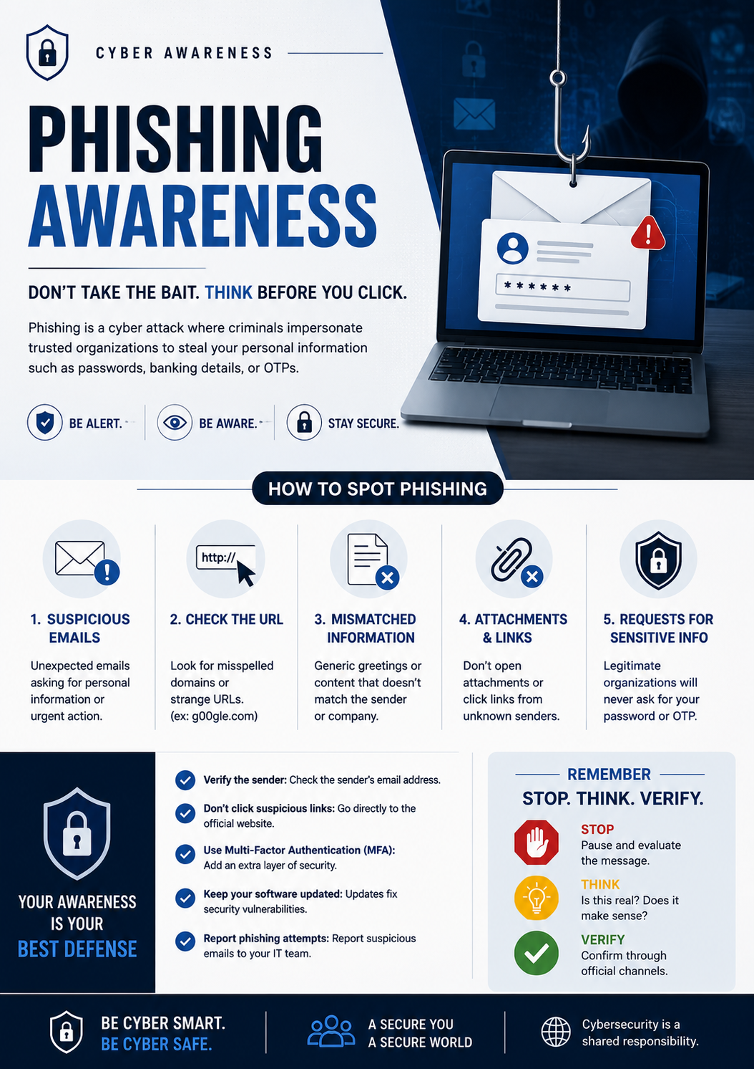
Figure 1 – Phishing Awareness Poster – “Don’t Take the Bait. Think Before You Click.”

E.1 – Key Messages from the Poster
- Phishing impersonates trusted organisations to steal passwords, banking details, and OTPs.
- Five warning signs: suspicious emails, mismatched URLs, mismatched information, dangerous attachments, and requests for sensitive data.
- Prevention steps: verify the sender, avoid clicking suspicious links, enable MFA, keep software updated, and report phishing attempts.
- The Stop • Think • Verify framework provides a memorable three-step decision process before acting on any message.

Part F Security Reflection
The following reflection addresses three questions: the cybersecurity risks identified in my own digital habits, the security improvements I will implement, and the broader importance of cybersecurity in today’s world.

F.1 – Cybersecurity Risks Identified in My Digital Habits
Completing this security audit provided a valuable and at times sobering perspective on my own digital practices. Several areas of concern emerged during the review:

- Browser-saved passwords: I had allowed my browser to save passwords for multiple services, which creates a single point of failure. If my browser profile or device is compromised, all stored credentials are at risk.
- Irregular patch habits: Although my system is currently up to date, I realised that in the past I had dismissed update notifications to avoid interruption, leaving my system exposed to known vulnerabilities for extended periods.
- Limited awareness of phishing: I had not previously considered how convincing modern phishing attempts can be. Reviewing the awareness poster made me more alert to the subtle cues that distinguish legitimate communications from impersonation attempts.
- Weak account-recovery options: Some older accounts had outdated recovery email addresses configured, meaning recovery codes could be sent to inboxes I no longer control.
- Public Wi-Fi exposure: I have previously connected to public Wi-Fi networks without using a VPN, potentially exposing unencrypted traffic to interception.

F.2 – Security Improvements I Will Implement Immediately
Based on the findings of this audit, I will immediately implement the following improvements:

- Install and use a dedicated password manager to eliminate browser-saved passwords and ensure every account uses a unique, randomly generated credential.
- Enable automatic updates across all applications and the operating system so that patches are applied without manual intervention.
- Audit all online accounts to update recovery email addresses and ensure they point to a currently active, secure inbox.
- Enable MFA on every account that supports it, with preference for authenticator apps over SMS codes (which are susceptible to SIM-swapping).
- Install a reputable VPN client and activate it whenever connecting to public or untrusted Wi-Fi networks.

F.3 – Why Cybersecurity Is Important in Today’s World
We live in an era where virtually every aspect of personal, professional, and governmental activity has migrated online. Banking, healthcare, education, communications, commerce, and critical infrastructure all depend on digital systems, and each of these systems represents a potential target. The consequences of a successful cyberattack can range from personal financial loss and identity theft to large-scale disruptions of hospitals, power grids, and government services.

The threat landscape has never been more dynamic. Nation-state actors conduct espionage and sabotage through cyber means. Organised criminal groups operate ransomware-as-a-service platforms that lower the barrier to entry for attackers. Individual hackers exploit unpatched systems and human errors to steal data for financial gain. The democratisation of attack tools — available freely on the internet — means that virtually anyone can launch a sophisticated attack with minimal technical expertise.

Cybersecurity is therefore not an optional or purely technical concern. It is a fundamental life skill for anyone who uses a smartphone, maintains an online account, or participates in the digital economy. Personal responsibility — practising good password hygiene, keeping software updated, recognising social engineering attempts, and enabling MFA — is the foundation upon which all other security measures rest. No firewall or antivirus can protect a user who willingly hands their credentials to a phishing site.

This task has reinforced my understanding that cybersecurity begins not with sophisticated tools but with awareness, disciplined habits, and a healthy scepticism toward the unexpected. The skills developed here form the groundwork for more advanced security analysis and, ultimately, for a career protecting the digital infrastructure that society depends upon.

“Security is a shared responsibility. Every strong password, every enabled MFA, every verified link is a contribution to a safer digital world.”
Prepared as part of Cyber Security Task 01 for White Band Associates by Pratiksha Vishwakarma

